1.Create a database Query:

- Use Current Database Query:
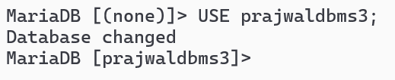
- Create tables
  - student (id, name, gender,program,contact_number,address):
Query:
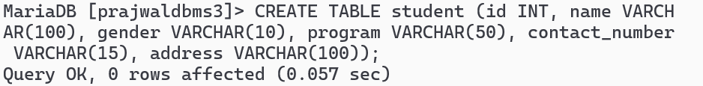

  - teacher (id, name, subject, contact_number, address ,email):
Query:
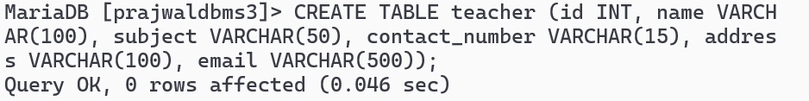
  - See detail of Tables:
a. Student:
Query:
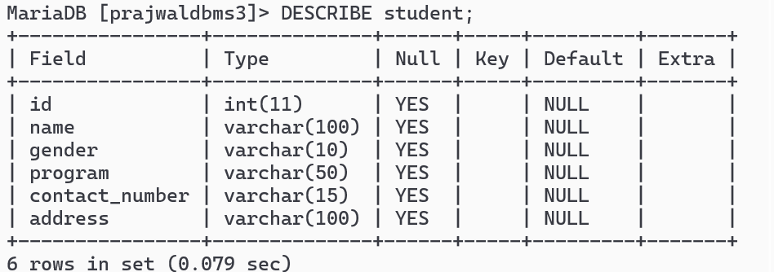
b. Teacher:
Query:
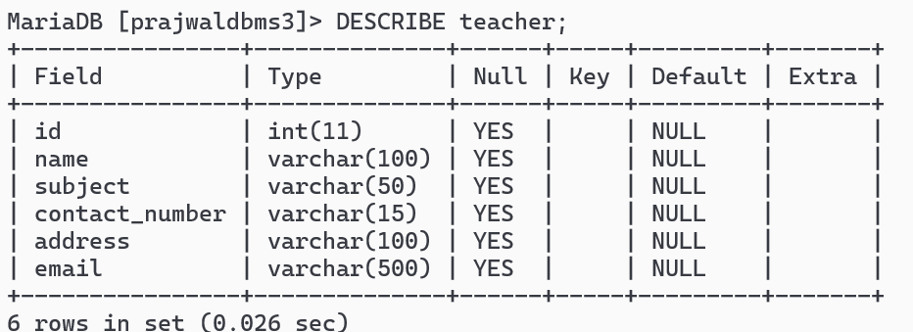
- Insert Sample Data in tables:
- Insert into student:
Query:

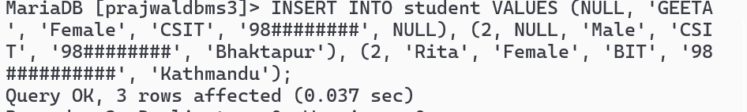
- Insert into teacher:
Query:

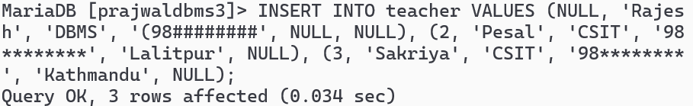
c.Check inserted data in tables;
- SELECT * FROM student;
Query:
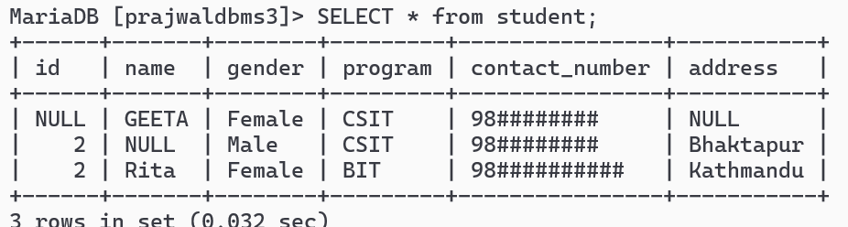

- SELECT * FROM teacher;
Query:
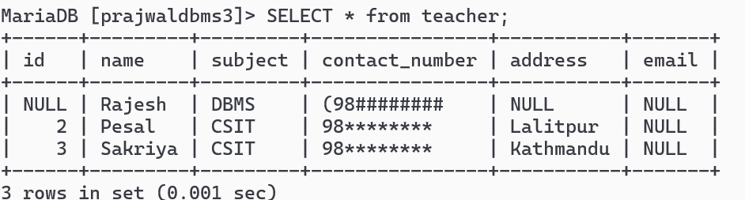
5. Add NOT NULL Constraints
- Add NOT NULL Constraint in student table for necessary attributes:
Query:
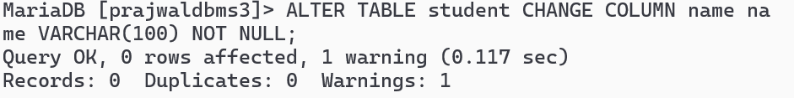
- Add NOT NULL Constraint in teacher table for necessary attributes:
Query:
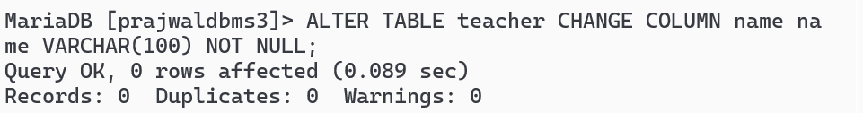
- INSERT INTO student (id, name) VALUES (3, NULL); Query:
6. Add UNIQUE Constraints (Require deletion of previous duplicate data:
- DELETE FROM <tablename>:
Query:
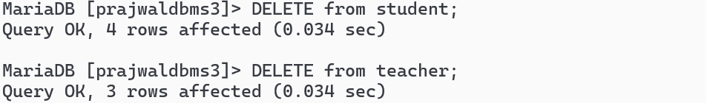
- Add UNIQUE Constraint in student table for necessary attributes:
a. ALTER TABLE student ADD CONSTRAINT uq_student_contact UNIQUE (contact_number):
Query:
- Add UNIQUE Constraint in teacher table for necessary attributes Query:
- Test violation of UNIQUE Constraint in tables by INSERTING DUPLICATE values:
Query:

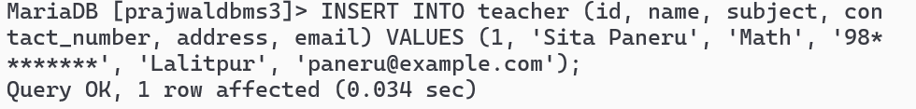
7.Set DEFAULT Values
a. Add DEFAULT Value in student table for necessary attributes

i.ALTER TABLE student MODIFY program VARCHAR(50) DEFAULT 'CSIT': Query:
ii. ALTER TABLE student CHANGE COLUMN program program VARCHAR (50) DEFAULT 'CSIT';
Query:
b. Add DEFAULT Value in teacher table for necessary attributes:
Query:

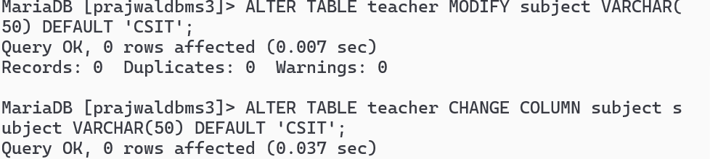
C. Test DEFAULT VALUES in rows after INSERTING BLANK values in attributes:
Query:

8. Set PRIMARY KEYS
- Add PRIMARY KEY in student table
i.ALTER TABLE student ADD PRIMARY KEY (id);
Query:
- Add PRIMARY KEY in teacher table:
Query:

9.Add ENUM and CHECK Constraints
a. Add ENUM and CHECK Constraints in student table
i.ALTER TABLE student MODIFY gender ENUM ('Male', 'Female', 'Other'); Query:
ii. ALTER TABLE student ADD CONSTRAINT chk_program CHECK
(program IN ('CSIT', 'BCA', 'BIT')); Query:
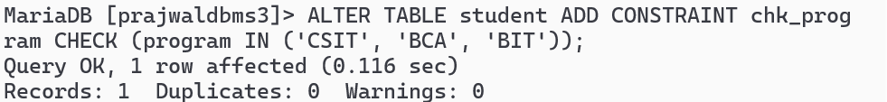

b . Add ENUM and CHECK Constraints in teacher table:
Query:
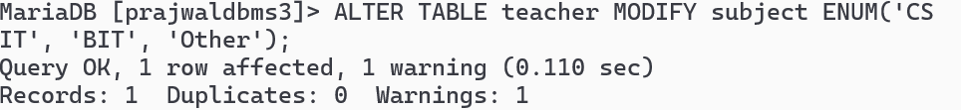

Query:
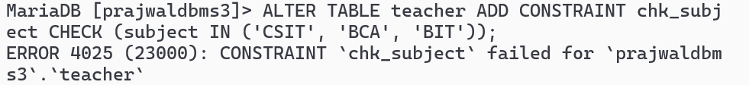
c. Test ENUM and CHECK Constraints in by INSERTING different values than enum and check values in respective attributes:
Query:
10. List all Constraints:
- SELECT CONSTRAINT_NAME, TABLE_NAME, CONSTRAINT_TYPE FROM information_schema.TABLE_CONSTRAINTS WHERE TABLE_SCHEMA = '<yourname>dbms3';
Query:
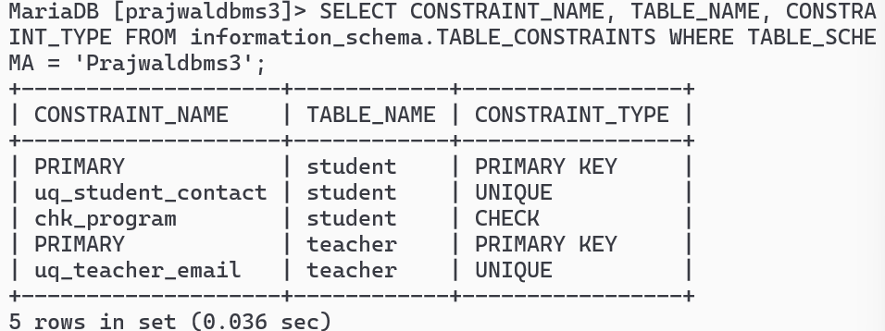

11.Delete All Constraints from tables;
a.DROP Constraints from student table
i.ALTER TABLE student DROP INDEX <constraint_name>; Query:
- DROP Constraints from teacher table Query:
Query:

- Test deletion of Constraints in by inserting values having duplicates in respective attributes
Query:
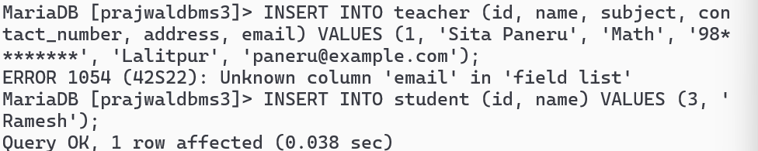

s

